**CAPSTONE PROJECT : UNIVERSITY SUCCESS ANALYSIS**

**ARKAPRAVA MAZUMDER**

***OVERVIEW***

**1.Data Sources:**

Country Data: Contains information about different countries.

Ranking System Data: Describes various ranking systems.

Criteria Data: Lists the criteria used for ranking universities.

University Data: Includes details about universities, their countries, and names.

Ranking Criteria Data: Connects universities with specific ranking criteria, ranking systems, and years.

Performance Data: Provides university-specific performance metrics such as scores, number of students, student-to-staff ratio, international student percentage, and female student percentage.

**2. Analysis Goals:**

Comparative Analysis: Compare universities based on their rankings, performance scores, and other criteria.

Trend Analysis: Identify trends in university performance over the years.

Demographic Analysis: Understand the diversity of student populations, including international and female students.

Ranking System Evaluation: Evaluate the effectiveness of different ranking systems.

Country-wise Analysis: Analyse the universities' performance and rankings based on their respective countries.

**3. Potential Insights:**

Top Universities: Identify top-performing universities based on ranking scores.

Performance Trends: Analyse how universities' performance scores have changed over the years.

Impact of Criteria: Understand which criteria (e.g., student-to-staff ratio, international student percentage) significantly affect rankings.

Diversity Analysis: Explore the correlation between international student percentage, female student percentage, and university rankings.

Country Comparisons: Compare universities across countries to identify patterns and trends.

**4. Deliverables:**

Visualizations: Charts, graphs, and dashboards illustrating key findings.

Reports: Detailed reports outlining methodologies, insights, and recommendations.

Presentations: Engaging presentations for stakeholders summarizing the analysis and its implications.

* *Data Retrieval from GitHub:*

The PROCESS

Acquired the necessary dataset from a designated GitHub repository, containing essential information about University Success Analysis. The dataset contained diverse countries and their universities with performance-based ranking.

* *Data Refinement and Enrichment:*

The procedures were done to ensure data quality and coherence. Furthermore, considered enhancing the dataset by introducing new problem scenarios that can amplify the depth of analysis.

* *Integration with Analytical Tools:*

Established connections between the dataset and various analytical tools. Linked the dataset with tools such as Power BI, Excel, and MySQL Workbench, to begin the process of data integration and processing.

* Problem-Solving through Power BI:

Utilized Power BI to address specific problem statements related to the University Success Analysis. Utilized its robust functionalities for visualizing, exploring, and analysing data, effectively unearthing insights and solutions.

* *Exploratory Data Analysis (EDA):*

Conducted exploratory data analysis using either Excel or SQL Workbench, based on the complexity of the analysis. Extracted meaningful patterns, correlations, and trends from the project data to guide subsequent decision-making.

* *Compelling and Informative Presentation Creation:*

Developed an all-encompassing PowerPoint presentation that encapsulates the project's aims, methodologies, solutions to problem statements, and pivotal visualizations. Each problem statement is accompanied by a dedicated section containing relevant conclusions and insights.

* *Comprehensive Documentation:*

Compiled a detailed report that meticulously outlines the entire project lifecycle. This documentation encompasses facets such as data acquisition, refinement, formulation of problem statements, integration of analytical tools, Power BI solutions, insights derived from exploratory data analysis, and the visualizations featured in the PowerPoint presentation.

University Success Analysis hold immense historical and cultural significance, but their analysis can be complex due to various factors like Ranking Criteria, System name, Student-staff ratio, University ranking. This project aims to comprehensively analyse University data through SQL, Excel, and Power BI to unveil insights about universities and trends across different countries.

**OBJECTIVES**

*Project Scope*

The project involves the following key tasks:

* Top countries for International Student for Higher Education.
* Universities faculty, ranking, alumina, placement.

*Project Objectives*

* Comprehensive Data Analysis: Employed SQL and Excel to dissect University data, revealing trends, statistical summaries, and insightful visualizations.
* Power BI Insights: Utilized Power BI's advanced capabilities to create interactive dashboards, providing deeper insights into University achievements region wise.
* Recommendations: Summarized analysis outcomes and derive meaningful conclusions to suggest potential enhancements for future University selection for Higher Study.

*Project Assessment*

The success of the project will be assessed based on:

* Analytical Depth: The data has been explored and insights derived.
* Visual Impact: The quality of Power BI dashboards and visualizations in conveying complex information.
* Recommendation Practicality: The feasibility and relevance of suggestions provided for improving future Universities Success.

Significance

The significance of this university analysis project lies in its potential to offer valuable insights and drive informed decision-making in various sectors related to education, policymaking, and research. Here are several key aspects highlighting the significance of this project:

**1. Informed University Choices:**

For Students: Prospective students can make informed decisions about which universities align with their preferences, academic goals, and desired international exposure.

**2. Educational Institutions:**

Performance Enhancement: Universities can identify their strengths and weaknesses, allowing them to focus on areas needing improvement and enhance their educational quality.

Strategic Planning: Data-driven insights can aid in strategic planning, helping universities set realistic goals and benchmarks for improvement.

**3. International Collaboration:**

Research Partnerships: Universities can use rankings to identify potential partners for research collaborations, fostering international cooperation and knowledge exchange.

**4. Research and Academia:**

Research Impact: Researchers can use ranking data to gauge the impact of universities, facilitating collaborations and providing a basis for academic research in the field of education and sociology.

Identifying Trends: Academics can identify trends in education, student demographics, and internationalization, leading to deeper studies and analysis.

**5. Competitive Advantage:**

Economic Impact: Countries with top-ranking universities can attract international students, contributing significantly to the local economy through tuition fees, accommodation, and other expenditures.

**6. Long-term Development:**

Human Capital Development: A strong education system, as indicated by university rankings, is crucial for developing a skilled workforce, fostering innovation, and driving economic growth in the long term.

In summary, this university analysis project holds immense significance as it not only helps individuals make informed decisions about their education but also influences policies, fosters international collaborations, supports research endeavours, and contributes to the overall development of societies and economies.

**id (Primary Key):** Unique identifier for records in various tables.

Data Dictionary

**country_name:** Name of the country where the university is located.

**ranking_system_id:** Identifier for the ranking system used for university rankings.

**criteria_name:** Name of the criteria used for ranking universities.

**system_name:** Name of the ranking system.

**country_id (Foreign Key):** Identifier linking universities to their respective countries.

**university_name:** Name of the university.

**university_id (Primary Key):** Unique identifier for universities.

**ranking_criteria_id (Primary Key):** Unique identifier for ranking criteria.

**year:** The year for which the ranking or performance data is reported.

**score:** The score assigned to the university based on ranking criteria.

**num_students:** Number of students enrolled in the university.

**student_staff_ratio:** Ratio of students to staff members in the university.

**pct_international_students:** Number of international students in the university.

**pct_female_students:** Number of female students in the university.

data model in excel

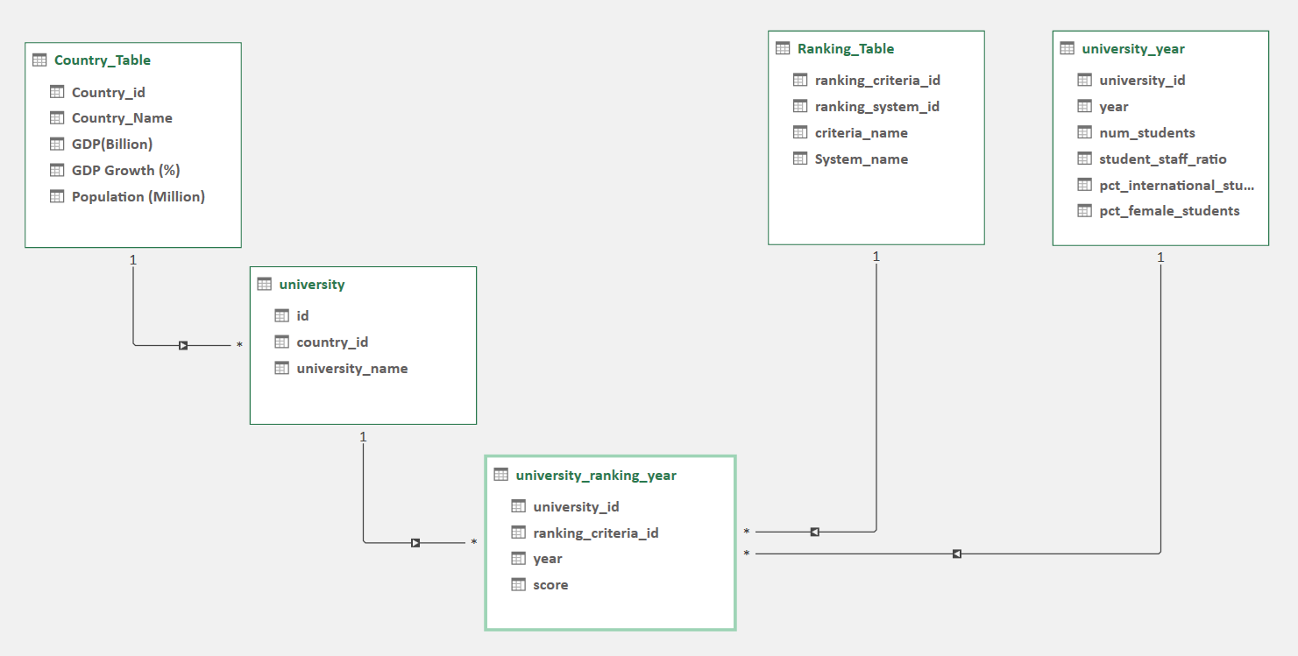

*EDA PROBLEM STATEMENT*

**Q. Is there a correlation between a country's GDP and the number of universities?**

**Correlation – 0.907**

**Conclusion –** It is showing that it has a positive correlation between Countries GDP and Number of University. The higher GDP has the higher number of University.

**Q. How has the number of universities changed over the years in each country?**

|  |  |  |  |  |  |  |  |  |  |  |  |
| --- | --- | --- | --- | --- | --- | --- | --- | --- | --- | --- | --- |
| Count of university_id | Column Labels |  |  |  |  |  |  |  |  |  |  |
| Row Labels | 2005 | 2006 | 2007 | 2008 | 2009 | 2010 | 2011 | 2012 | 2013 | 2014 | 2015 |
| Argentina |  |  |  |  |  |  |  |  |  | 32 | 24 |
| Australia | 7 | 7 | 7 | 14 | 14 | 14 | 63 | 79 | 85 | 265 | 271 |
| Austria | 7 |  |  |  |  |  | 12 | 6 | 6 | 102 | 102 |
| Belgium |  |  |  |  |  | 7 | 19 | 25 | 31 | 124 | 118 |
| Brazil |  |  |  |  |  |  |  | 6 | 6 | 144 | 144 |
| Bulgaria |  |  |  |  |  |  |  |  |  | 8 | 8 |
| Canada | 28 | 28 | 28 | 28 | 28 | 28 | 58 | 106 | 108 | 326 | 340 |
| Chile |  |  |  |  |  |  |  |  |  | 32 | 32 |
| China |  |  |  |  |  |  | 30 | 18 | 12 | 684 | 682 |
| Colombia |  |  |  |  |  |  |  |  |  | 16 | 16 |
| Croatia |  |  |  |  |  |  |  |  |  | 8 | 8 |
| Cyprus |  |  |  |  |  |  |  |  |  | 8 | 8 |
| Czech Republic |  |  |  |  |  |  |  |  |  | 40 | 40 |
| Denmark | 7 | 7 | 7 | 14 | 14 | 14 | 32 | 40 | 40 | 72 | 72 |
| Egypt |  |  |  |  |  |  | 6 |  |  | 32 | 32 |
| Estonia |  |  |  |  |  |  |  |  |  | 8 | 8 |
| Finland | 7 | 7 | 7 | 7 | 7 | 7 | 13 | 21 | 21 | 85 | 85 |
| France | 14 | 14 | 14 | 7 | 7 | 7 | 31 | 77 | 96 | 462 | 448 |
| Germany | 7 | 7 | 14 | 14 | 7 | 7 | 85 | 103 | 82 | 514 | 526 |
| Greece |  |  |  |  |  |  |  |  |  | 56 | 56 |
| Hong Kong |  |  |  |  |  |  | 24 | 24 | 24 | 66 | 72 |
| Hungary |  |  |  |  |  |  |  |  |  | 48 | 48 |
| Iceland |  |  |  |  |  |  |  |  |  | 8 | 8 |
| India |  |  |  |  |  |  |  |  |  | 120 | 128 |
| Iran |  |  |  |  |  |  |  |  |  | 64 | 64 |
| Ireland |  |  |  |  |  |  | 12 | 12 | 12 | 76 | 70 |
| Israel |  |  |  |  |  |  |  | 51 | 57 | 68 | 62 |
| Italy |  |  |  |  |  |  |  | 8 | 8 | 376 | 382 |
| Japan | 28 | 35 | 35 | 21 | 28 | 28 | 58 | 91 | 92 | 636 | 643 |
| Lebanon |  |  |  |  |  |  |  |  |  | 8 | 8 |
| Lithuania |  |  |  |  |  |  |  |  |  | 8 | 8 |
| Malaysia |  |  |  |  |  |  |  |  |  | 24 | 24 |
| Mexico |  |  |  |  |  |  |  |  |  | 16 | 16 |
| Netherlands | 14 | 14 | 14 | 14 | 14 | 14 | 74 | 102 | 101 | 204 | 198 |
| New Zealand |  |  |  |  |  |  | 6 | 6 | 6 | 54 | 54 |
| Norway | 7 | 7 | 7 | 7 | 7 | 7 | 13 | 27 | 15 | 53 | 53 |
| Poland |  |  |  |  |  |  |  |  |  | 72 | 72 |
| Portugal |  |  |  |  |  |  |  |  |  | 56 | 56 |
| Puerto Rico |  |  |  |  |  |  |  |  |  | 8 | 8 |
| Romania |  |  |  |  |  |  |  |  |  | 8 | 16 |
| Russia |  |  |  |  |  |  |  |  | 8 | 24 | 46 |
| Saudi Arabia |  |  |  |  |  |  |  |  |  | 32 | 32 |
| Serbia |  |  |  |  |  |  |  |  |  | 8 | 8 |
| Singapore |  |  |  |  |  |  | 12 | 12 | 20 | 28 | 28 |
| Slovakia |  |  |  |  |  |  |  |  |  | 8 | 8 |
| Slovenia |  |  |  |  |  |  |  |  |  | 16 | 16 |
| South Africa |  |  |  |  |  |  | 6 | 6 | 6 | 46 | 46 |
| South Korea |  |  |  |  |  |  | 24 | 26 | 32 | 296 | 312 |
| Spain |  |  |  |  |  |  | 12 | 6 |  | 334 | 326 |
| Sweden | 28 | 28 | 28 | 28 | 21 | 21 | 39 | 59 | 59 | 139 | 139 |
| Switzerland | 14 | 14 | 14 | 14 | 14 | 14 | 57 | 95 | 95 | 135 | 135 |
| Taiwan |  |  |  |  |  |  | 24 | 6 | 6 | 206 | 174 |
| Thailand |  |  |  |  |  |  |  |  |  | 24 | 24 |
| Turkey |  |  |  |  |  |  | 6 |  |  | 86 | 104 |
| Uganda |  |  |  |  |  |  |  |  |  | 8 | 8 |
| United Arab Emirates |  |  |  |  |  |  |  |  |  | 8 | 8 |
| United Kingdom | 49 | 49 | 49 | 49 | 49 | 49 | 204 | 286 | 272 | 721 | 724 |
| United States of America | 280 | 280 | 287 | 287 | 287 | 287 | 687 | 1175 | 1172 | 2560 | 2556 |
| Uruguay |  |  |  |  |  |  |  |  |  | 8 | 8 |

**Q. Is there a relationship between a country's population and the number of universities?**

**Correlation - 0.3264**

**Conclusion –** Correlation between population and number of universities are not dependent strongly, but we can see theless number of populations have less number of universities.

**Q. Are there any common criteria used by different ranking systems?**

|  |  |  |  |
| --- | --- | --- | --- |
| Average of score | Column Labels |  |  |
| Row Labels | 1 | 2 | 3 |
| Harvard University | 82 | 96 | 14 |
| University of Cambridge | 86 | 70 | 25 |
| University of California, Berkeley | 80 | 69 | 21 |
| Stanford University | 85 | 68 | 17 |
| California Institute of Technology | 90 | 65 | 47 |
| Princeton University | 86 | 59 | 48 |
| Columbia University | 84 | 59 | 21 |
| University of Chicago | 82 | 56 | 39 |
| University of Oxford | 90 | 55 | 22 |
| Yale University | 78 | 53 | 29 |

**Conclusion -** Here we can see the better of ranking criteria that university are well known for studies and research.

**Q. How many students does a specific university have in a particular year?**

|  |  |  |  |  |  |  |
| --- | --- | --- | --- | --- | --- | --- |
| Average of num_students | Column Labels |  |  |  |  |  |
| Row Labels | 2011 | 2012 | 2013 | 2014 | 2015 | 2016 |
| Indian Institute of Technology Kharagpur | 24128 | 26832 | 16742 | 11911 | 20358 | 22195 |

**Q.** **How does the choice of ranking system affect a university's international student enrolment?**

**Correlation : - 0.0936**

**Conclusion –** International student admission are not dependent on University Ranking.

**Q. What is the student-staff ratio for a specific university in a particular year?**

|  |  |  |  |  |  |  |
| --- | --- | --- | --- | --- | --- | --- |
| Average of student_staff_ratio | Column Labels |  |  |  |  |  |
| University_Ranking | 2011 | 2012 | 2013 | 2014 | 2015 | 2016 |
| Indian Institute of Technology Bombay | 15.67 | 17.66 | 19.54 | 17.10 | 17.26 | 22.69 |

**Q. What percentage of international students does a specific university have over year?**

|  |  |  |
| --- | --- | --- |
| University_Ranking | Average of num_students | Average of pct_international_students |
| **Indian Institute of Technology Delhi** |  |  |
| 2011 | 24128 | 19 |
| 2012 | 26832 | 17 |
| 2013 | 16742 | 15 |
| 2014 | 11911 | 23 |
| 2015 | 20358 | 11 |
| 2016 | 22195 | 14 |

**Q. Is there a relationship between a university's score and the student-staff ratio?**

**Correlation : 0.1768**

**Conclusion –** Though correlation between Student-Staff ratio is not strong, but we can see that less number of student staff ratio the more scored have that university.

**Q. How does the number of female students differ among universities?**

**Correlation: - 0.0146**

**Conclusion –** We can see the better number of university ranking has the more number of female students have.

**Q. What is the distribution of universities across different countries?**

|  |  |
| --- | --- |
| Row Labels | Distinct Count of id |
| Argentina | 4 |
| Australia | 35 |
| Austria | 12 |
| Bangladesh | 1 |
| Belarus | 1 |
| Belgium | 11 |
| Brazil | 27 |
| Bulgaria | 1 |
| Canada | 37 |
| Chile | 7 |
| China | 96 |
| Colombia | 4 |
| Croatia | 1 |
| Cyprus | 1 |
| Czech Republic | 10 |
| Denmark | 6 |
| Egypt | 5 |
| Estonia | 2 |
| Finland | 10 |
| France | 68 |
| Germany | 68 |
| Ghana | 1 |
| Greece | 8 |
| Hong Kong | 6 |
| Hungary | 6 |
| Iceland | 1 |
| India | 22 |
| Indonesia | 1 |
| Iran | 11 |
| Ireland | 10 |
| Israel | 8 |
| Italy | 54 |
| Japan | 81 |
| Jordan | 2 |
| Kenya | 1 |
| Latvia | 1 |
| Lebanon | 1 |
| Lithuania | 1 |
| Luxembourg | 1 |
| Macau | 1 |
| Malaysia | 8 |
| Mexico | 3 |
| Morocco | 1 |
| Netherlands | 14 |
| New Zealand | 7 |
| Nigeria | 1 |
| Norway | 6 |
| Oman | 1 |
| Pakistan | 2 |
| Poland | 12 |
| Portugal | 9 |
| Puerto Rico | 1 |
| Qatar | 1 |
| Romania | 4 |
| Russia | 13 |
| Saudi Arabia | 4 |
| Serbia | 1 |
| Singapore | 2 |
| Slovakia | 2 |
| Slovenia | 2 |
| South Africa | 6 |
| South Korea | 37 |
| Spain | 43 |
| Sweden | 12 |
| Switzerland | 12 |
| Taiwan | 29 |
| Thailand | 7 |
| Turkey | 15 |
| Uganda | 1 |
| Ukraine | 2 |
| United Arab Emirates | 2 |
| United Kingdom | 89 |
| United States of America | 273 |
| Uruguay | 1 |

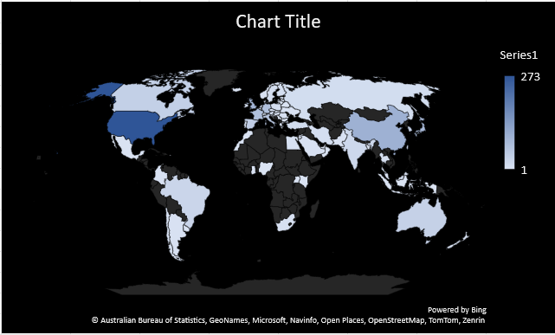

**Q. What percentage of female students does a specific university have in a given year?**

|  |  |  |
| --- | --- | --- |
| University_Ranking | Average of num_students | Average of pct_female_students |
| **Jadavpur University** |  |  |
| 2011 | 24127.71 | 48.98 |
| 2012 | 26832.00 | 54.64 |
| 2013 | 16742.14 | 41.60 |
| 2014 | 11911.00 | 43.20 |
| 2015 | 20357.56 | 43.44 |
| 2016 | 22195.00 | 54.29 |

**Q. What is the trend in the percentage of female students over time?**

|  |  |  |
| --- | --- | --- |
| Row Labels | Total Students | Total Female students |
| 2011 | 4463626 | 8376 |
| 2012 | 858624 | 1530 |
| 2013 | 117195 | 208 |
| 2014 | 59555 | 216 |
| 2015 | 183218 | 391 |
| 2016 | 155365 | 380 |

**Q. How has the ranking score of universities evolved over the years In India?**

|  |  |  |
| --- | --- | --- |
| Average of score | Column Labels |  |
| Row Labels | 2014 | 2015 |
| All India Institute of Medical Sciences, New Delhi | 508.13 | 556.63 |
| Banaras Hindu University | 443.75 | 475.63 |
| Indian Institute of Science | 347.13 | 320.50 |
| Indian Institute of Technology Bombay | 390.63 | 411.75 |
| Indian Institute of Technology Delhi | 433.25 | 463.13 |
| Indian Institute of Technology Kanpur | 366.75 | 430.38 |
| Indian Institute of Technology Kharagpur | 438.00 | 475.13 |
| Indian Institute of Technology Madras | 370.25 | 421.50 |
| Indian Institute of Technology Roorkee | 494.25 | 511.63 |
| Jadavpur University | 521.88 | 518.38 |
| Jawaharlal Nehru Centre for Advanced Scientific Research | 439.25 | 476.50 |
| Panjab University | 416.13 | 432.63 |
| Tata Institute of Fundamental Research | 376.63 | 409.38 |
| University of Calcutta |  | 459.00 |
| University of Delhi | 434.50 | 456.25 |
| University of Hyderabad | 552.38 | 583.50 |

**Q. Is there a relationship between a university's ranking score and the number of students over time?**

**Correlation : -0.0699**

**Conclusion –** Though number of students and score has not strong correlation, but we can see the less number of students has in university the less scored they scored.

**DASHBOARD**

*Power BI Problem Statements*

**DATA MODEL**

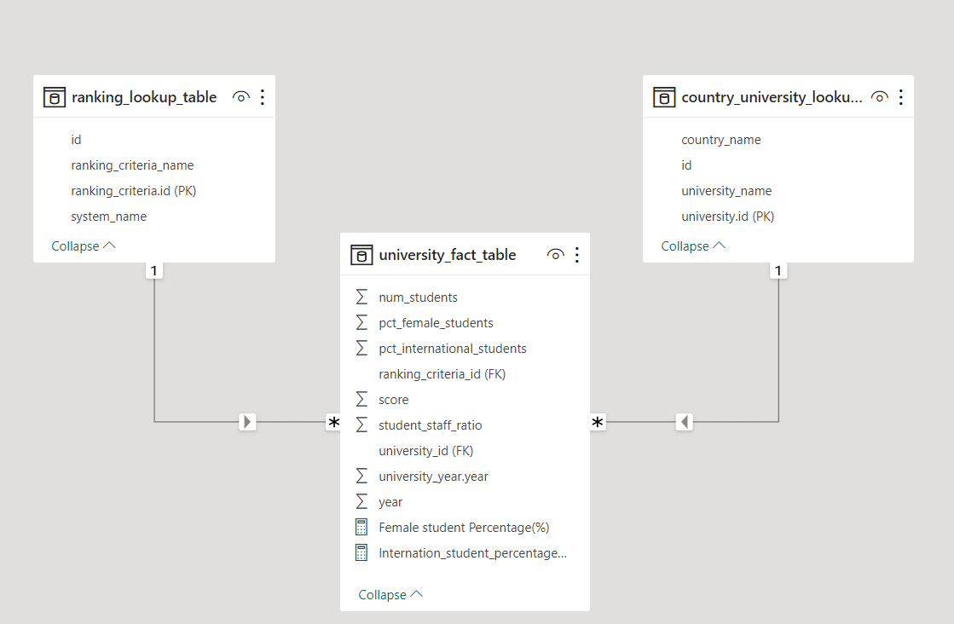

**Q. How many universities are there in each country?**

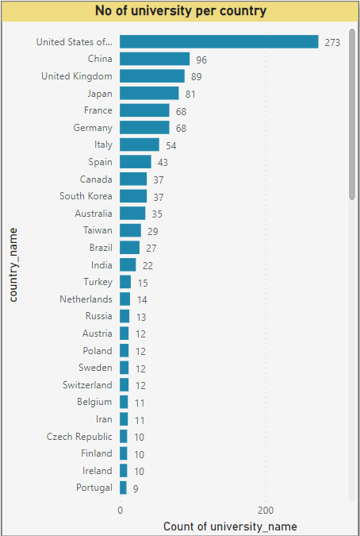

As we can see America Leads the race for most number of University followed by China and UK.

**Q.2 ) What is the distribution of international students across different countries?**

Conclusion: United States, UK, Australia, Canada is most preferred Country for abroad study

**Q.3 ) Which country has the highest number of female students enrolled in universities?**

**Q.4 ) What is the average score for universities according to each ranking system?**

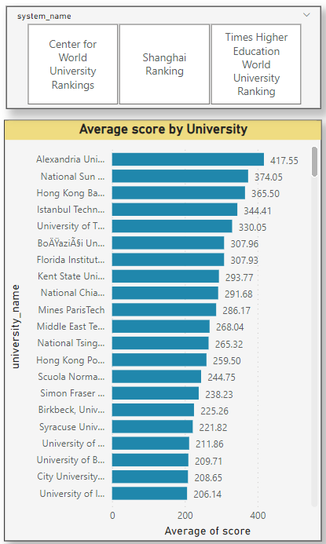

You can navigate Ranking System in attached Power BI files, to see the difference in each ranking system.

**Q.5 ) How does the ranking system affect a university's student-staff ratio?**

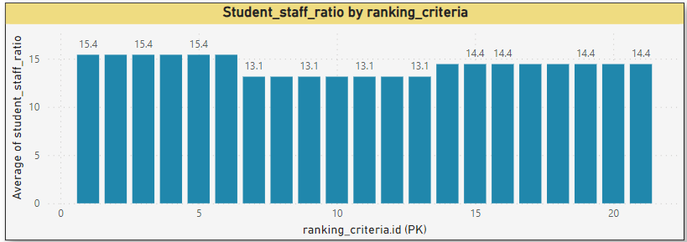

**Q.6 ) What are the most important criteria considered by ranking systems?**

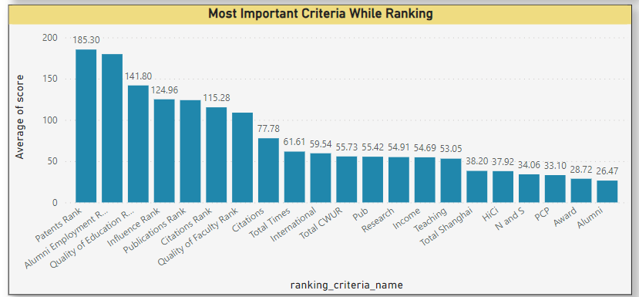

We can see the **Patents Rank, Alumni Employment Rate, Quality of Education** are the most important criteria for Ranking.

**Q.7 ) Is there a correlation between a university's score and the number of international students?**

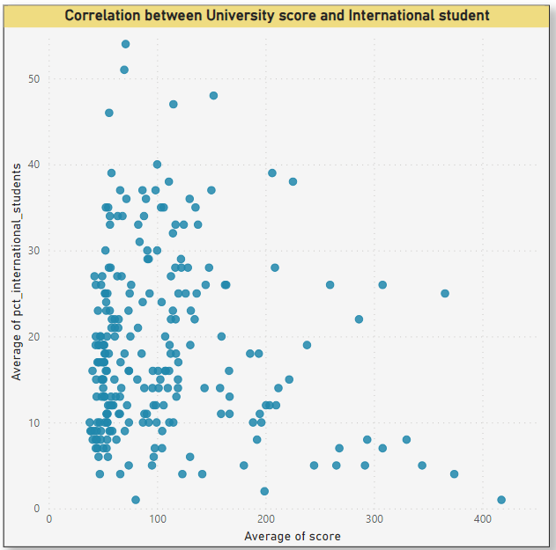

**Q.8 ) How does the percentage of female students impact a university's ranking?**

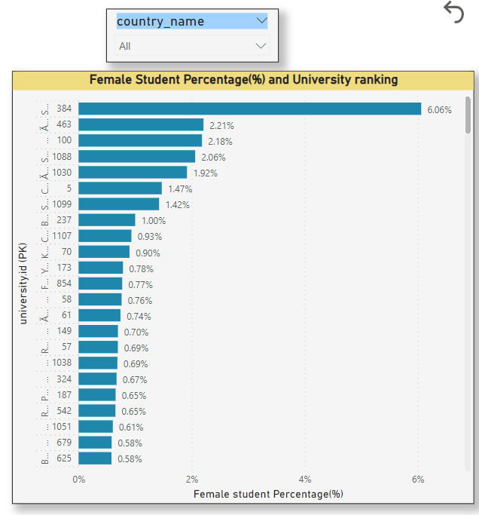

**Q.9 ) Which university has the highest number of students?**

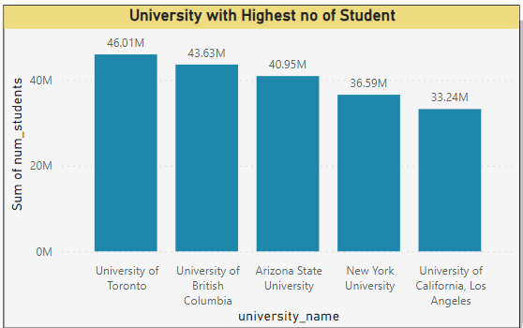

**Q.10 ) How does the percentage of international students vary across different universities?**

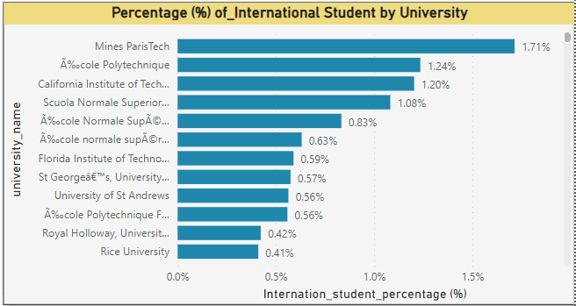

**Q.11 ) Is there a correlation between a university's ranking and its student-staff ratio?**

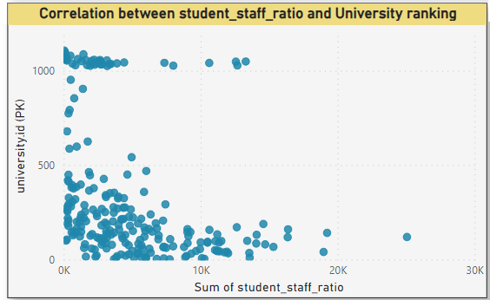

Conclusion: Here we can see that the higher rate of Student-staff ratio the better University Ranking

**Q.12 )What is the correlation between score and student-staff ratio?**

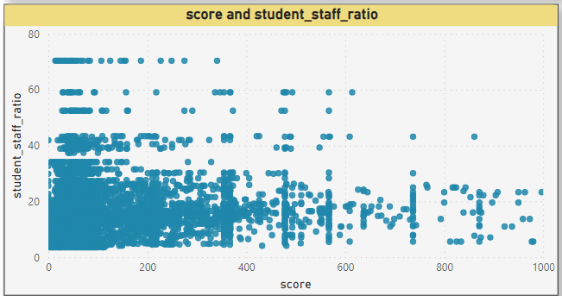

**Q.13 ) Is there a correlation between a university's ranking score and the student-staff ratio over the years?**

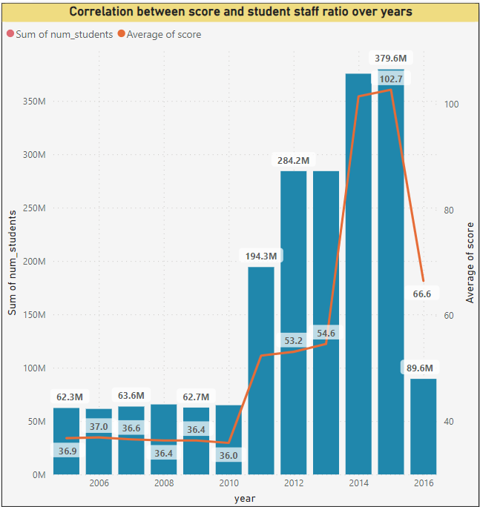

**Q.14 ) How does the percentage of international students vary across different years?**

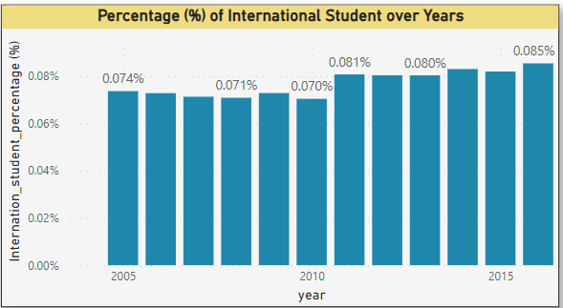

**Conclusion : Slowly international students percentage increased over years.**

**Q.15 ) What is the impact of a university's ranking on the number of international students it attracts?**

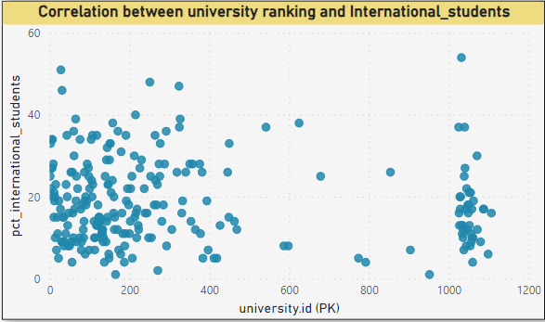

Conclusion – Though numbers relation between university ranking and International students that not strong, but we can see that International student prefer better University Ranking Institute.

**Q.16 ) Is there a relationship between a university's ranking score and the percentage of female students enrolled?**

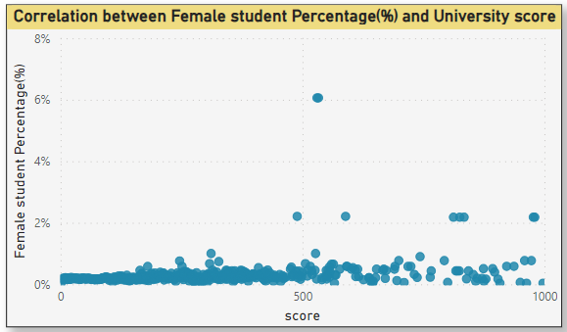

**Q.17 ) How does the percentage of international students affect a university's student-staff ratio?**

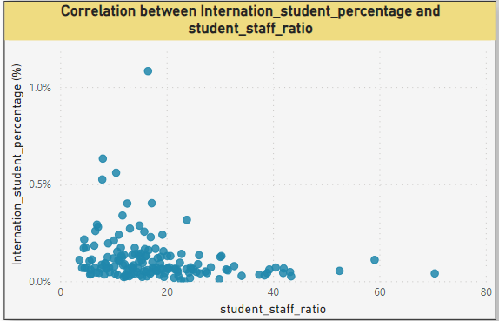

**Q.18 ) Are there any significant trends or patterns in the rankings of universities from different countries?**

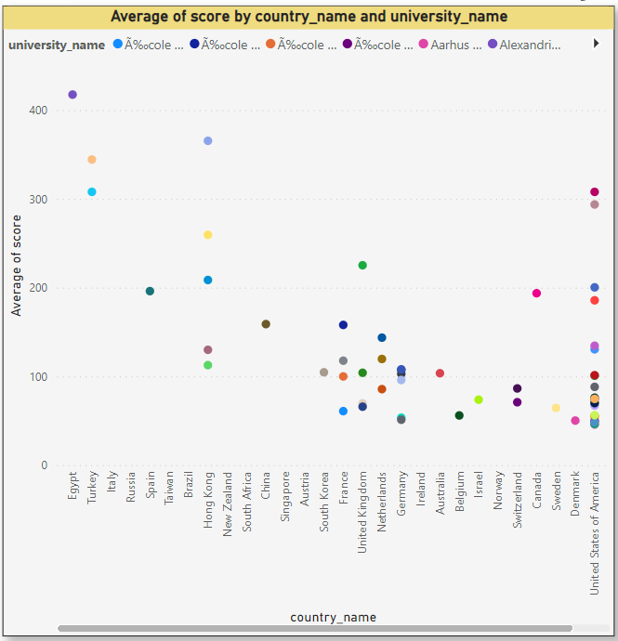

Conclusion – Most of the Countr’s University score are below 200.